# SQL Assignment-3

**Q1. Use the following functions->**

1. **chr (n): note-here n is a number**

**select chr(99) from dual;**

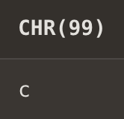

1. **concat(char1,char2):**

**select concat('manan ','mehra') from dual;**

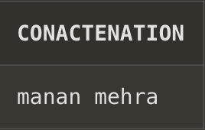

1. **instr(string,char): - it gives the index of character in string,indexing starts from 1 and if the character is not present in sring it will return 0.**

**select instr('Rohan','R') from dual;**

**select instr('Rohan',’h') from dual;**

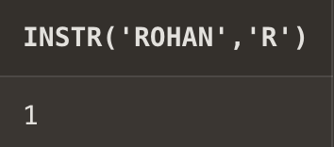 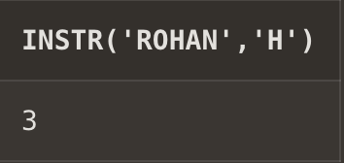

1. **length(n):(here n is the input which can be a string,number,etc)-returns the number of character in the given input(space also counted as one character).**

**select length('manna.@') from dual;**

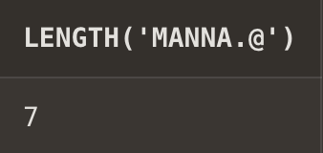

1. **Lpad(char1 ,n ,[char2]): Left-pad the string(char1) with char2, to a total length of n.**

**select Lpad('my name is manan',28,'ABC') from dual;**

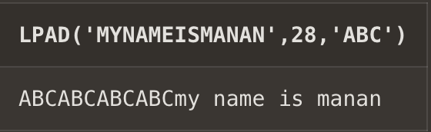

1. **Ltrim(string ,[char(s)]): remove all the extra spaces before the first element to be printed**

**select(Ltrim(' my name is manan mehra')) from dual;**

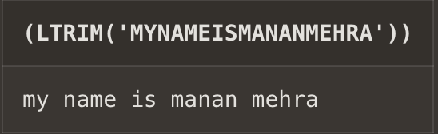

**proof-> select(length(' my name is manan mehra')) from dual;**

**select length(Ltrim(' my name is manan mehra') )from dual;**

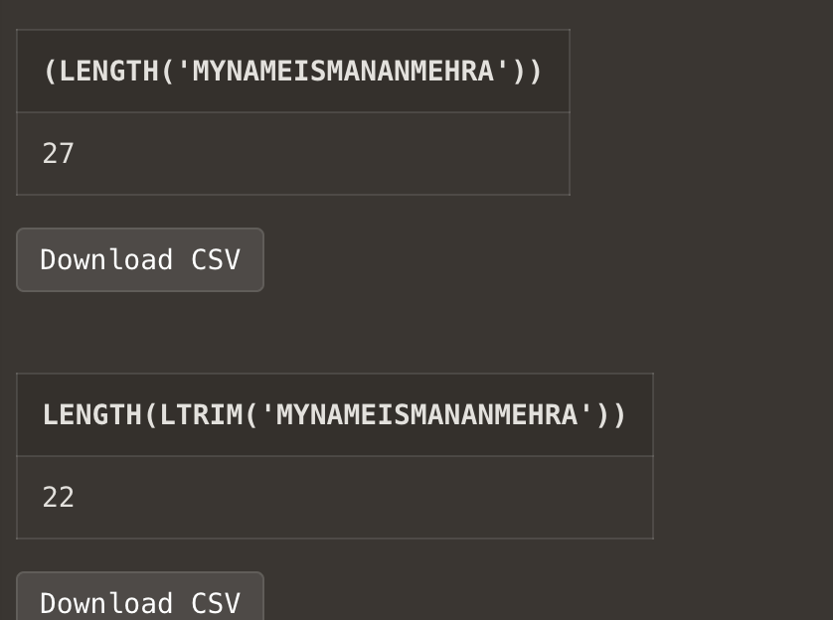

1. **rpad(char1 ,n [,char2]): Right-pad the string(char1) with char2, to a total length of n.**

**select rpad('my name is manan',28,'ABC') from dual;**

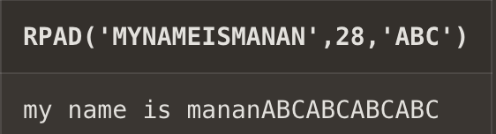

1. **rtrim(string [,char(s)]):**

**select(rtrim(' my name is manan mehra ')) from dual;**

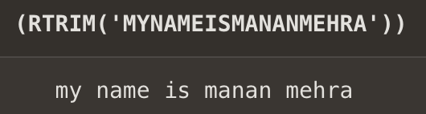

1. **replace(char ,search_string , replacement_string):**

**syntax-replace(orignal string,part of string u want to replace,part with which u want to replace)**

**select replace('hello world','world','universe') from dual;**

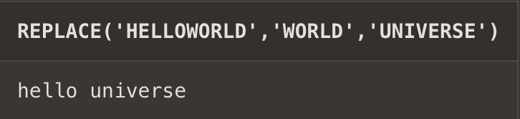

1. **substr(string ,position ,substring length): Extract a substring from a string (start at position pos, extract n characters):**

**syntax-substr(string,position to start from(pos),number of characters you want(n))**

**select substr('mananananananannannaanan',1,5) from dual;**

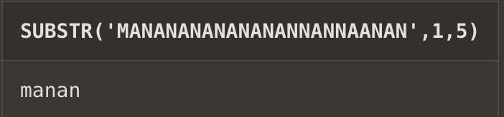

1. **initcap(char): make first letter of every word of the string captital is small**

**select initcap('my name is manan 28') from dual;**

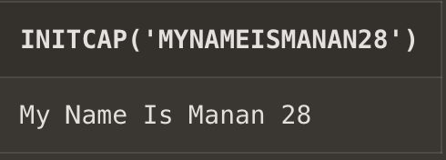

1. **lower(string): converts all capital letters to small letters.**

**select lower('MaNaN MeHrA') from dual;**

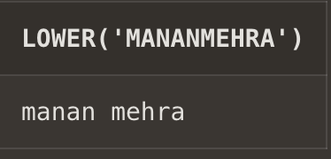

1. **upper(string): converts all small letters in the string to capital letters.**

**select upper('vikas Mehra') from dual;**

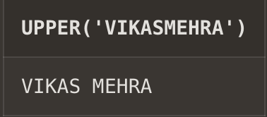

1. **translate(char ,from string(string1) ,to string(string2)): Return the string from the first argument AFTER the characters specified in the second argument are translated into the characters specified in the third argument.**

**select translate('Amananas','manas','vikas') from dual;**

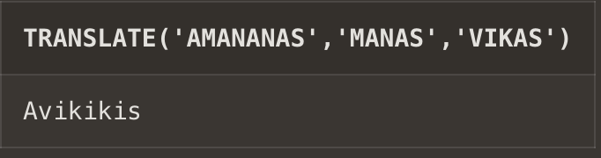

**note- string1 and string2 should have same length or same number of characters.**

1. **abs(n): returns absolute value of a number**

**select abs(-77) from dual;**

**select abs(-22/3) from dual;**

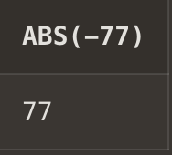 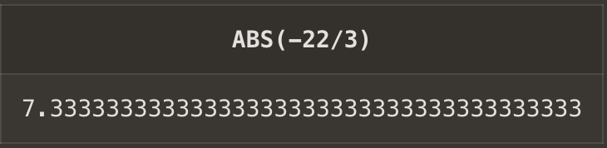

1. **ceil(n):**

**select ceil(12.0000009) from dual;**

**select ceil(-2.9999999) from dual;**

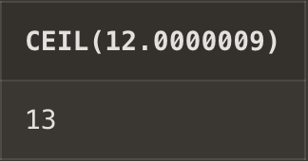 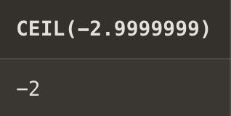

1. **cos(n):**

**select cos(30) from dual;**

**select cos(-56) from dual;**

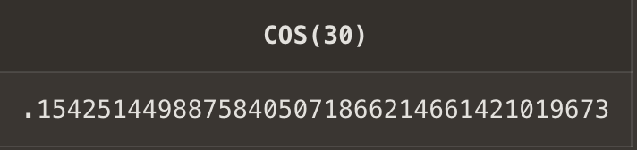 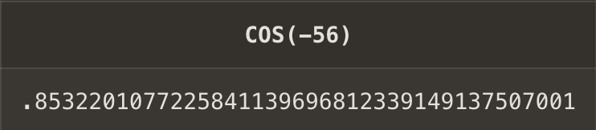

**note- return values in radians.**

1. **exp(n):**

**select exp(2) from dual;**

**select exp(-3) from dual;**

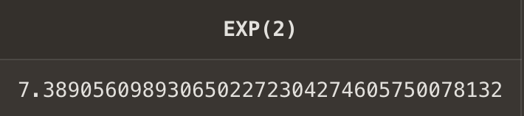 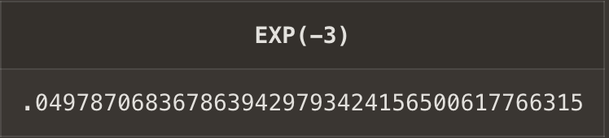

1. **floor(n):**

**select floor(12.999999) from dual;**

**select floor(-2.000009) from dual;**

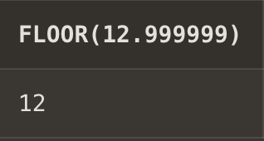 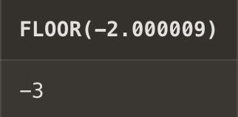

1. **mod(m ,n): returns remainder**

**select mod(23,10) from dual;**

**select mod(30,10) from dual;**

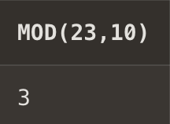 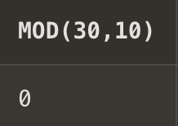

1. **power(x ,y):**

**select power(2,3)from dual;**

**select power(2,0.00001) from dual;**

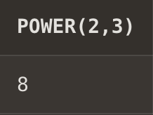 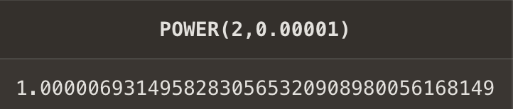

1. **round(x,y):**

**syntax:- round(floating number,till which decimal place you want to round of the number.**

**select round(2,3)from dual;**

**select round(2.344,2) from dual;**

**select round(2.345,2) from dual;**

**select round(2.346,2) from dual;**

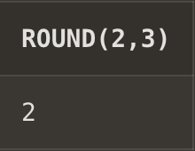 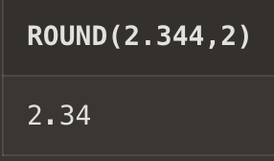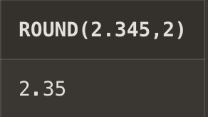 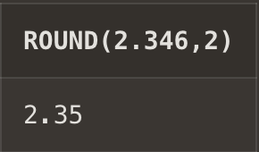

1. **sign(n):**

**select sign(-23) from dual;**

**select sign(67) from dual;**

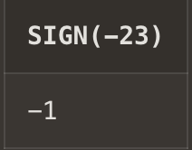 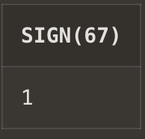

1. **sqrt(n);**

**select sqrt(-23) from dual;**

**select sqrt(67) from dual;**

**select sqrt(2.5) from dual;**

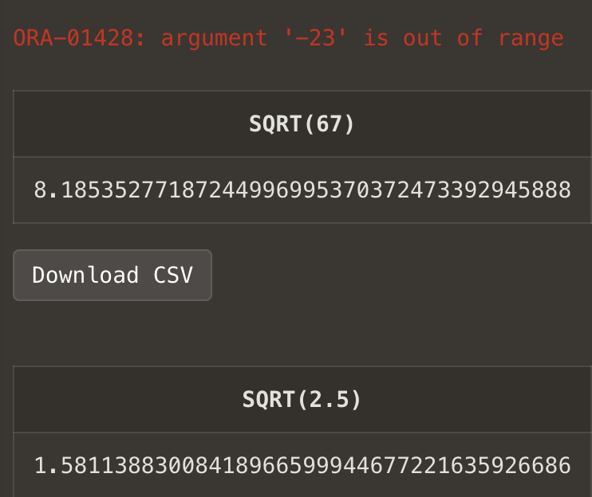

1. **trunc(x ,n): Return a number truncated to 2 decimal places.**

**select trunc(123.4546,2) from dual;**

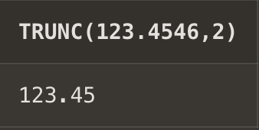

1. **sysdate:**

**select sysdate from dual;**

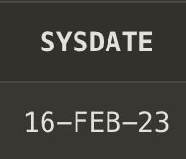

1. **add_months(d ,n):**

**syntax: add_months(‘date’,num)**

**select add_months('12-JAN-2023',12) from dual;**

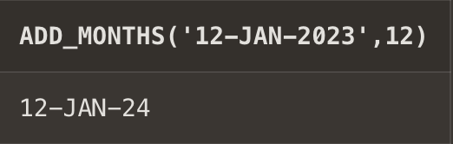

1. **last_day():**

**select last_day('01-JAN-2023') from dual;**

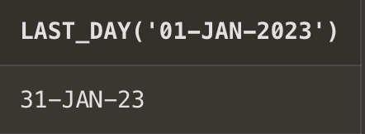

1. **months_between(date1 ,date2):**

**select months_between('20-JAN-2033','20-MAY-2013') from dual;**

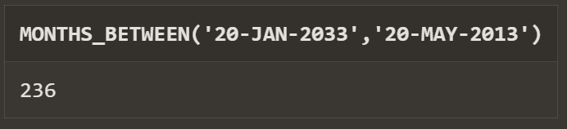

1. **next_day(date ,char):**

**select next_day('21-JUN-2023','Sunday') from dual;**

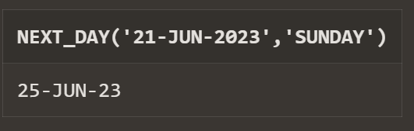

1. **greatest(expr):**

**select greatest(3,6,7,43,98,87) from dual;**

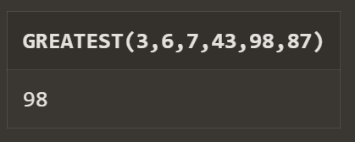

1. **least(expr):**

**select least(3,6,7,43,98,87) from dual;**

